STAYCONNECTED

User Manual

Version 1.0 / 12-8-2014

**Table of Contents**

1. Introduction and Technologies

2. User Functionality

* 2a. Creating a New Account
* 2b. Login
* 2c. Logout

3. Student Functionality

* 3a. View All Job Listings
* 3b. Search Listings
* 3c. View All Profiles
* 3d. Edit Profile

4. Faculty and Alumni Functionality

* 4a. Create a Job Listing
* 4b. View Your Own Listings
* 4c. Edit a Job Listing
* 4d. Remove a Job Listing

5. Admin Functionality

* 5a. Update Account Status
* 5b. Update Account Roles
* 5c. Update Job Listing Status

6. Additional Notes

**1. Introduction and Technologies**

Welcome to the StayConnected User Manual! This document will illustrate how to get the most out of your new system, whether you’re a current student or a recent alumnus. With StayConnected, you can connect with current students, faculty, and alumni of your university’s Computer Science department, post job listings, edit information within the system, and search for specific information across all registered job listings and users.

Job listings and users are the two primary sources of information within the system. A job listing typically contains the name of the company in question, the position’s name, a brief description of the position, the position’s location, and the email address of the user who posted the listing. A user’s profile typically lists the following information:

* First Name
* Last name
* Email address
* Phone number
* Address
* City
* State
* Country

Before we get into the functionality of the system, here are a few of the technical details. StayConnected is built upon version 1.6 of the Java Development Kit and runs on version 8.0.14 of the Apache Tomcat server, and it is recommended that you use these technologies when attempting to install the system. Further configuration can be performed after the .war file included in this package is successfully installed and deployed on your servers.

**2. User Functionality**

The StayConnected system supports four different types of users, and each type has access to different functions. However, there are certain functions that every user can access, and this section will detail those functions. The sections that follow will detail more specific functionality that registered users have access to.

*2a. Creating a New Account*

Upon accessing the system for the first time, users will see a login screen similar to the one pictured on the left with a button that allows them to create a new account. Clicking that button will bring users to a form that will prompt them to type in multiple pieces of identification information. Once the form is completed, users can submit the information, and they will receive a confirmation that lists some of their account information along with a reassurance that the account will be active within 48 hours.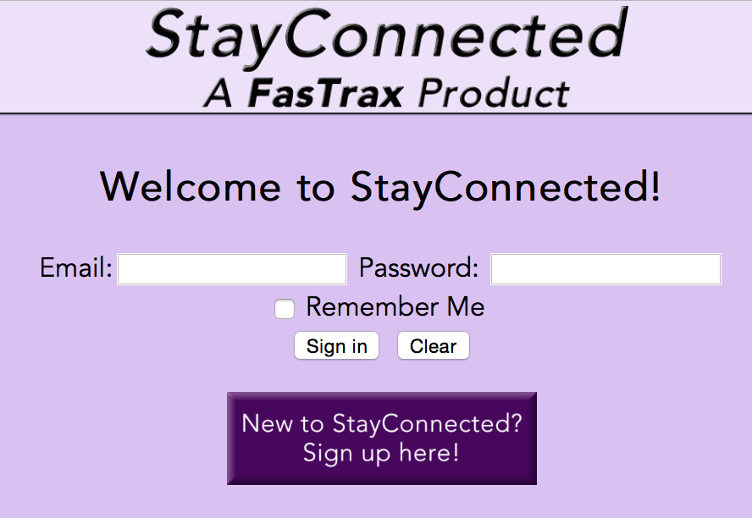

*2b. Login*

Once a user’s account is activated within the system, he or she can then log in. At the home screen pictured above, a user can enter their email address and password. If the information was entered correctly, the user will be brought to the account home page, where they can then begin to use the system. If the user’s account is inactive or they enter incorrect login information, the system will return an error message and the user will not be granted access to the system.

*2c. Logout*

At any time after a user has successfully logged in, he or she can click a link on the top right-hand corner of every page and log out. The system will log the user out, and he or she will be returned to the home page, where they can then log in again.

**3. Student Functionality**

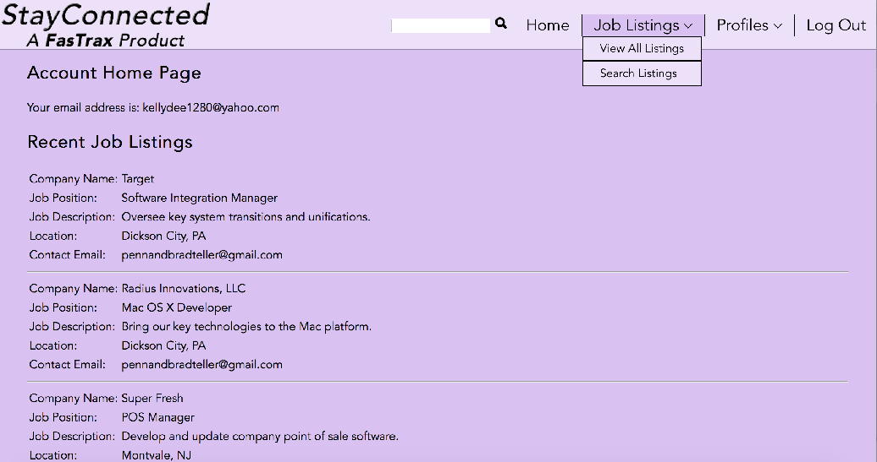

Upon signing in, current students will see their account home page as it appears in the picture above. Students will have access to some of the system’s functionality, though there are additional functions that they cannot access. This section details every action that a student is able to perform.

*3a. View All Job Listings*

Although they cannot post new listings, students can view all job listings that are active within the system. To do this, they must click the “View All Listings” option under Job Listings in the navigation bar; they will then be brought to a page that shows every listing available in the system. These listings will present information to the user as detailed in the introduction to this manual.

*3b. Search Listings*

Students can also search all active listings; they can do this in one of two ways. By clicking “Search Listings” under Job Listings in the navigation bar, they can search all active listings by querying for information in one or more of a listing’s fields. Alternately, students can search all fields in all listings by using the search bar located in the navigation bar itself. In either event, searches will display all information from the job listings returned by said search if relevant listings were found. If no listings were found, the system displays a message telling users this information.

*3c. View All Profiles*

Students can view the profiles of all users active within the system. To do this, they must click the “View All Profiles” option under the Profiles section of the navigation bar. This will bring them to a screen that lists all active users in the system. The system will attempt to display all fields of information as detailed in the introduction to this manual; if a user declined to enter information into any of the optional fields, those fields will be left blank on the View All Profiles screen.

*3d. Edit User Profile*

Students can also edit the information in their user profile by clicking the “Edit My Profile” option under the Profiles section of the navigation bar. They must first confirm their password for security purposes, but once they do, they are brought to a page with input fields for their profile populated with the information that the system already has. Users are then free to edit that information. Once they are done, they can submit that new information, and they will be brought to a confirmation page that shows their updated profile.

**4. Faculty and Alumni Functionality**

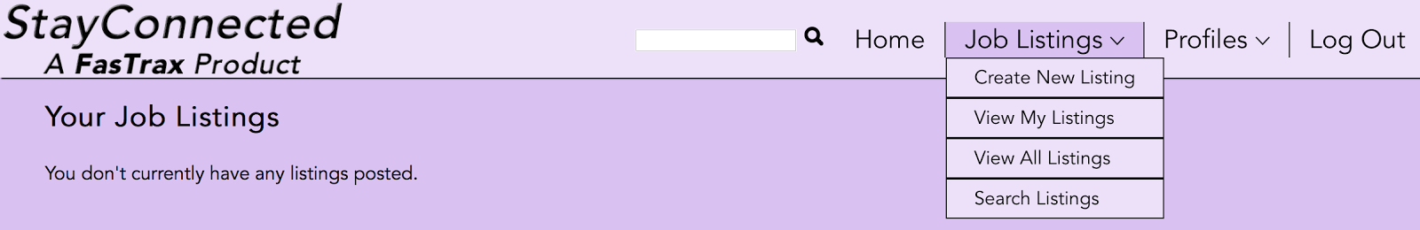

Faculty and alumni users have access to all of the functionality detailed above in the Student Functionality section. However, as evidenced by the screenshot above, they also have some additional functionality that allows them to create and interact with their own job listings. This section details that additional functionality.

*4a. Create a Job Listing*

Faculty and alumni can post their own job listings to make your university’s community aware of a possible opportunity on or off-campus. To do this, they can click on the “Create New Listing” option under the Job Listings section of the navigation bar. Once they do, they will see a form prompting them to input information about the listing. After they input information and submit the form, the system will bring them to a confirmation page that lists the information they just entered.

*4b. View Your Own Listings*

Faculty and alumni can also view all of the listings they have posted on a screen separate from the rest of the system’s active listings. They can do this by clicking on the “View My Listings” option under the Job Listings section of the navigation bar. Once they do, they will be brought to a page that lists all of their active job listings, if they have any. If that user has no active listings, the system will instead notify them that they have no active listings.

*4c. Edit a Job Listing*

Faculty and alumni can edit the information in any job listings they post. They can do this by clicking the “Update” button under the job listing in question on either the View All Listings or View My Listings page. This will bring the user to a page that has all of the information for that listing in an editable input form. The user is then free to edit any of the information in the listings and submit their changes. Upon submission, the user then receives a confirmation page that shows the updated listing information.

*4d. Remove a Job Listing*

Faculty and alumni can also remove any of their listings and make them unable to be viewed by other users. They can do this by clicking the “Remove” button under the job listing in question on either the View All Listings or View My Listings page. This will bring the user to a confirmation page telling the user that the listing in question has been deactivated. This does not delete the listing, but it does deactivate it so that users cannot see it in their listings anymore.

**5. Administrator Functionality**

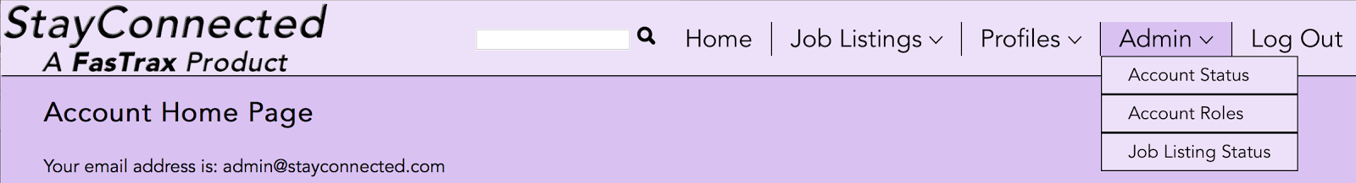

Administrators have access to all of the functionality detailed in the previous two sections. However, as evidenced by the screenshot above, they also have powerful additional functionality that only Administrators have access to. This section details that functionality.

*5a. Update Account Status*

Administrators can update the status of any user account. They can do this by clicking on the “Account Status” option under the Admin section of the navigation bar. Upon doing so, the admin will see a table that lists every user in the system with radio buttons to activate or deactivate that account. The admin can then toggle the state of the account by clicking the inactive radio button and updating the status. The system will then return a confirmation page detailing those updates. Note that this must be performed to activate new users in the system.

*5b. Update Account Roles*

Administrators can also update a user’s roles in the system. They can do this by clicking on the “Account Roles” option under the Admin section of the navigation bar. Upon doing so, the admin will see a list of all user accounts with checkboxes that denote each account’s current role or roles in the system. The admin can change the roles of each user by checking or unchecking each respective role and submitting those changes. The system will then return a confirmation page detailing those updates.

*5c. Update Job Listing Status*

Finally, administrators can update the status of all job listings in the system. They can do this by clicking on the “Job Listing Status” option under the Admin section of the navigation bar. Upon doing so, the admin will see a table that shows every job listing in the system with radio buttons to activate or deactivate that listing. The admin can then toggle the state of the listing by clicking the inactive radio button and updating the status. The system will then return a confirmation page detailing those updates.

**6. Additional Notes**

This section contains additional noteworthy information about your StayConnected system that you should be aware of prior to using the system for the first time in an active production environment.

Initial iterations of the system had a bug in which the functionality of updating job listings did not work properly; this issue has since been addressed. If you encounter any additional problems in regard to core functionality, please contact your vendor right away. Also, please note that this version of the StayConnected system utilizes a user interface that is designed only for computer monitors with a horizontal resolution of 1100 pixels or greater. Attempting to access the system on a mobile device or a system with an unsupported resolution may result in the displacement of site elements that will disrupt the user experience.

Note that the initial Administrator account needs to be created and configured server-side; there is currently no way to create that account through the system itself. However, once the initial admin account is created, further admin accounts can be activated using the system. Future updates to StayConnected may add the ability for users to make their profile information private so that it does not appear for other users. Users will also be able to search users’ profiles much as they are currently able to search job listings.

Thank you again for choosing StayConnected, and enjoy your new system!